ICAR-CENTRAL INLAND FISHERIES RESEARCH INSTITUTE
(INDIAN COUNCIL OF AGRICULTURAL RESEARCH)
BARRACKPORE: KOLKATA - 700 120
Phone No. (033) 2592 1190/1191
E-mail: cifri@vsnl.com, Website: cifri.res.in

F. No. Swachh Bharat/Adm.II/ | Dated 26th February, 2018

Action taken report on Swachh Bharat Abhiyan for the month of February, 2018:-

Activity at ICAR-CIFRI, Barrackpore:-
To turn Kitchen Waste into Compost under Swachh Bharat Abhiyan
ICAR-CIFRI took an initiative to imbibe the concept of ‘Swachhta’ in MGMG adopted village Ariala, Barasat-1, North 24-Pargana District on 6th February,2018. In this MGMG adopted village two Women Self Help Groups namely Ma Sarda Group and Karunamayi Group are working on Organic Farming. To turn kitchen waste to compost an awareness camp was conducted by ICAR-CIFRI by using the Platform of ‘Sabala Mela’ which was organized by the self help groups. Dr. U.K Sarkar, HOD, RWF division and Dr. Aparna Roy,Scientist ,Extension and Training Cell sensitize the women regarding biodegradable waste that can convert into compost and can also be used as fertilizer. Dr. A.K Das, I/C e & T Cell and Sri M.Roy, STA was also present in the programme. A green dustbin was given by ICAR-CIFRI to encourage the women of that village to turn the kitchen waste into compost..
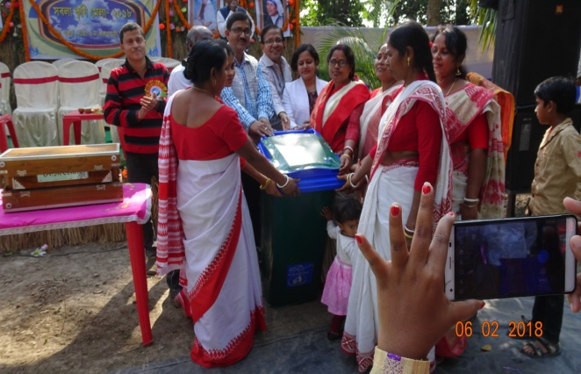
Photos above:- The Officials of ICAR-CIFRI handing over a green dustbin to encourage the women of Ariala village to turn the kitchen waste into compost.

Activity at ICAR-CIFRI, Bangalore:-
As a part of Swachh Bharat Abhiyan, cleaning activities were conducted in Research Centre, ICAR-CIFRI, Bangalore on 9th February, 2018. All scientists and staff of the centre actively participated in the cleaning process. Weeds and dry leaves were removed from lawn and office premises. Pots were cleaned and prepared for plantation.
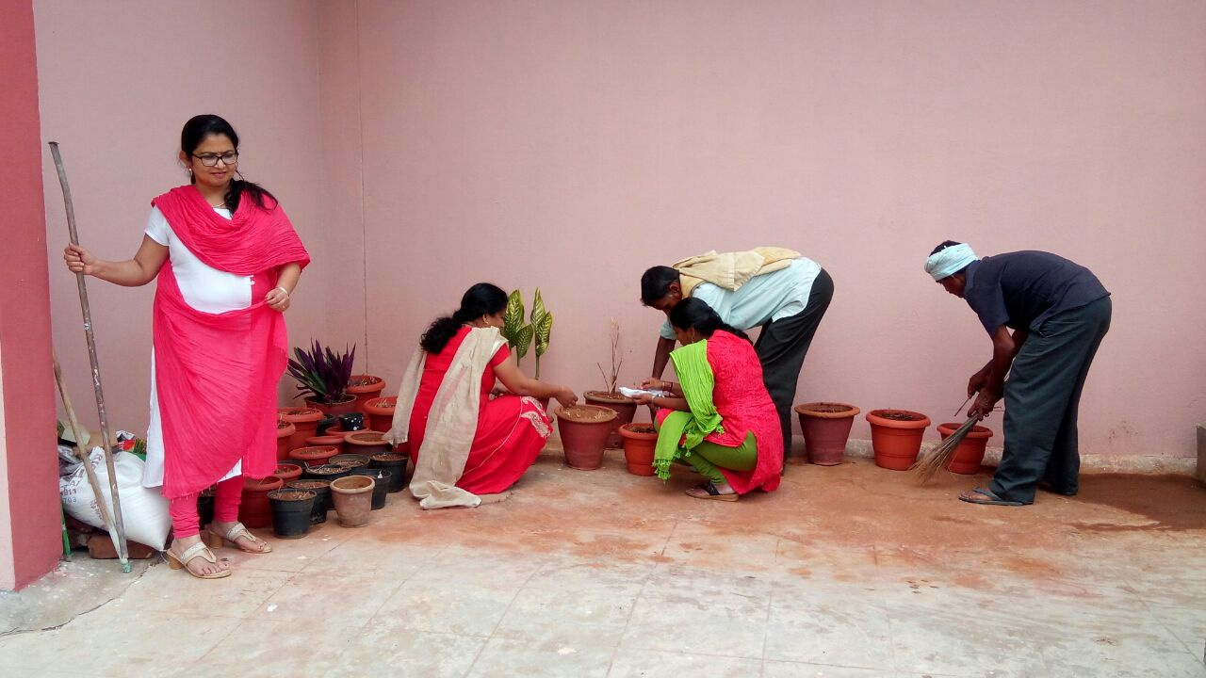
Cleaning activity in Office garden
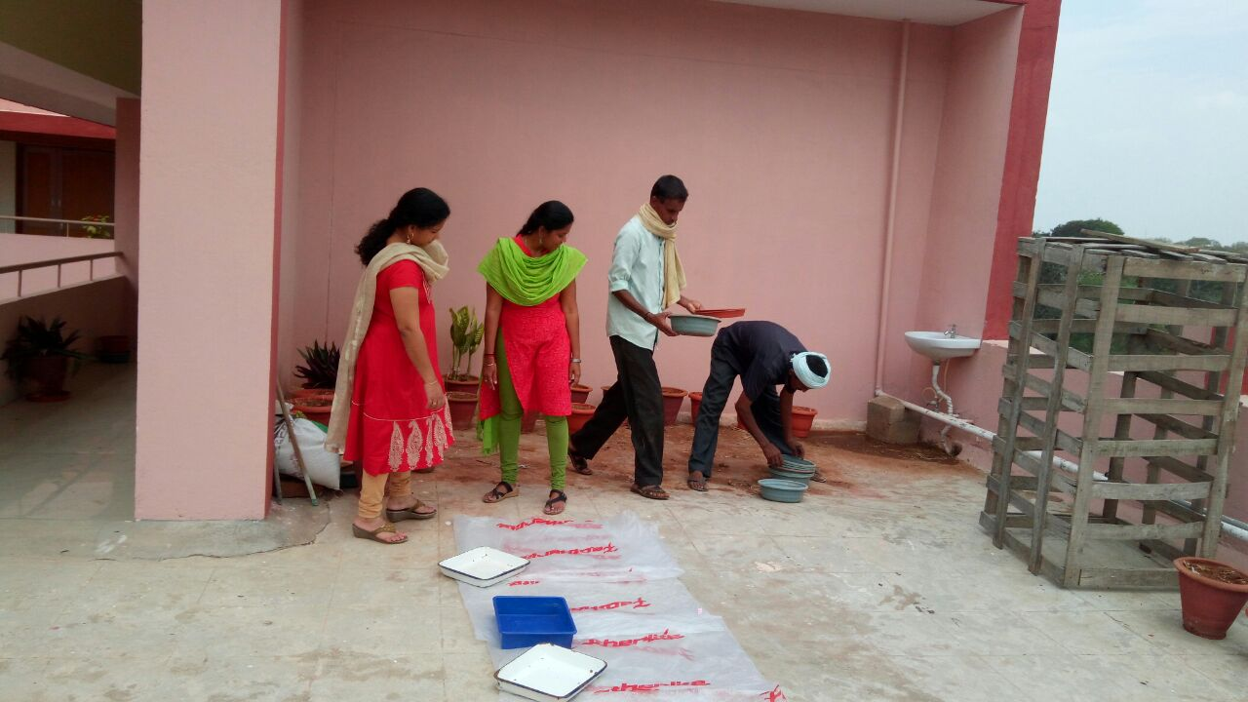
Cleaning activity in Office garden
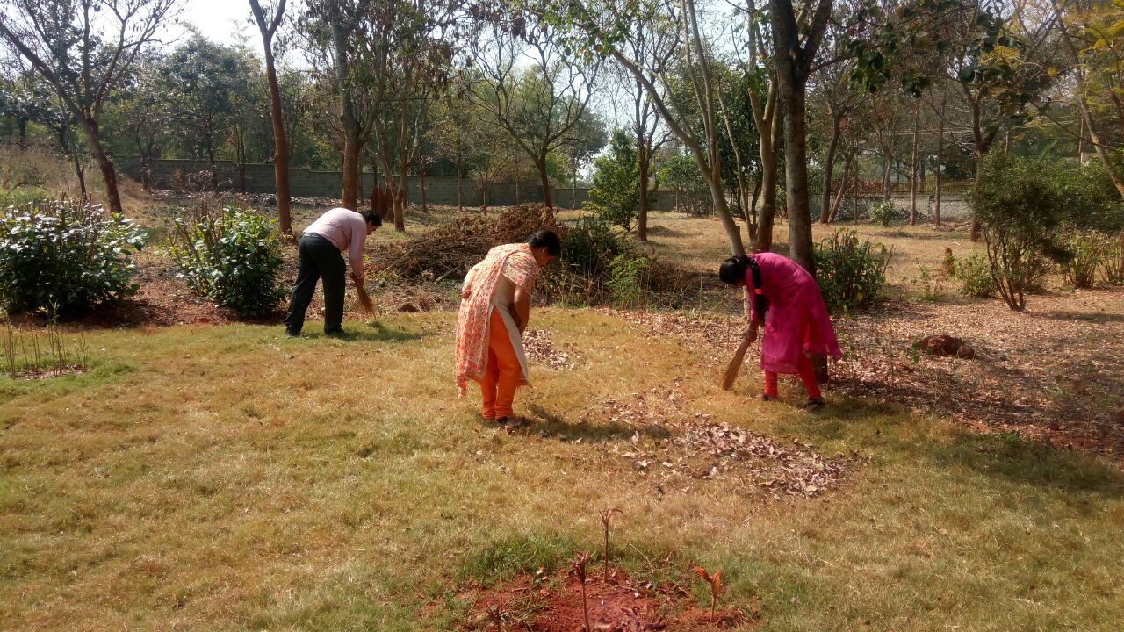
Cleaning activity in Office garden
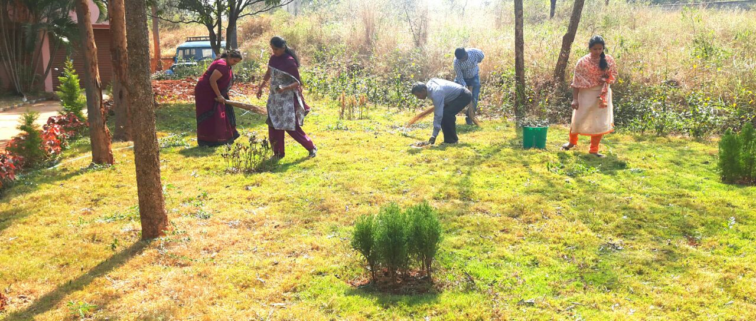
Cleaning activity in Office garden
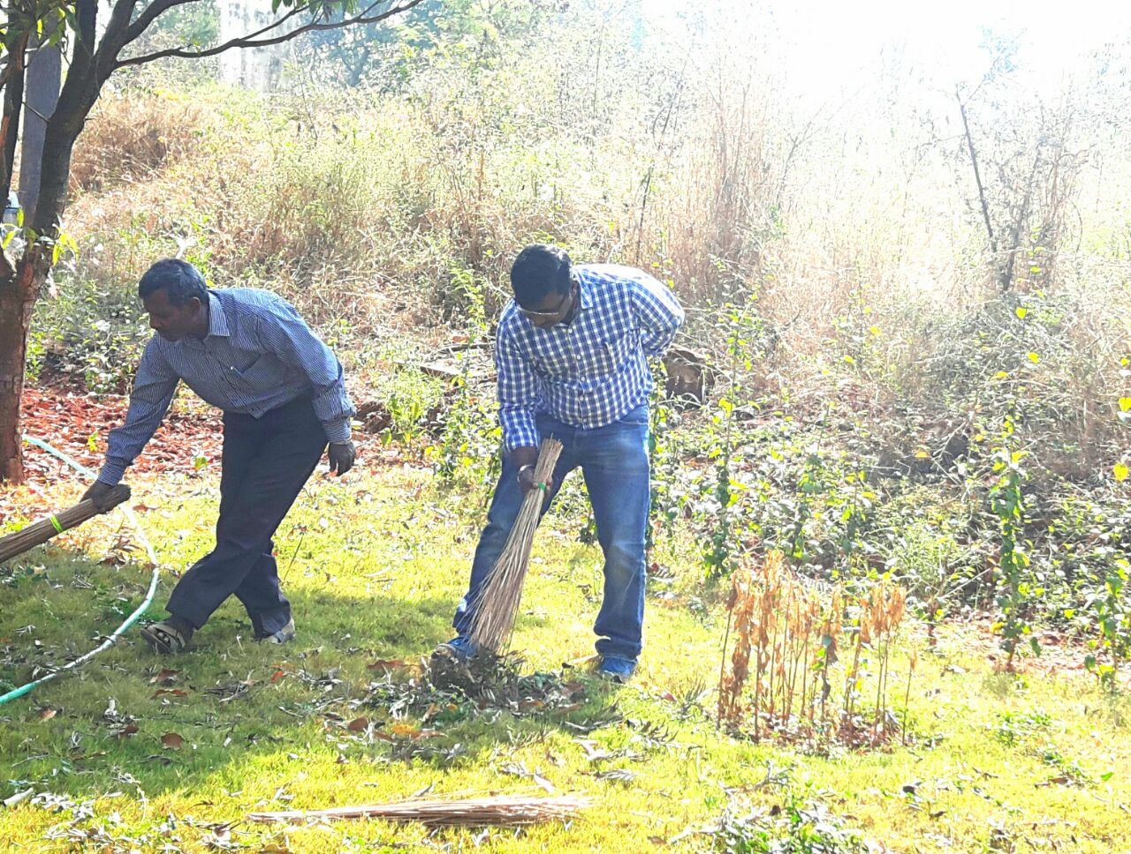
Cleaning activity in Office garden

Activity at ICAR-CIFRI, Kochi:-
Swachh Bharat for February, 2018 was carried out at this centre on 20.02.2018 by the Officers and Staffs of the centre in the office premises. All the cupboards were cleaned by clearing all the scraps such as plastic, waste papers, broken materials of consumables and carton boxes. The collected items were discarded appropriately based on disposal methods.
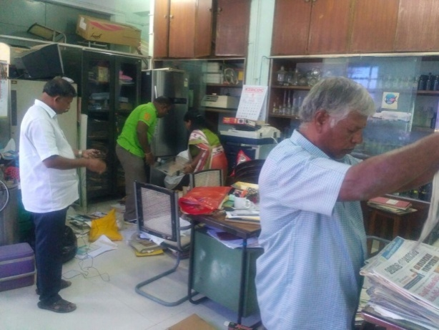
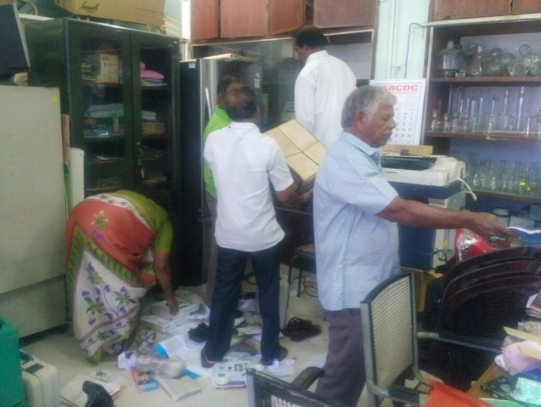

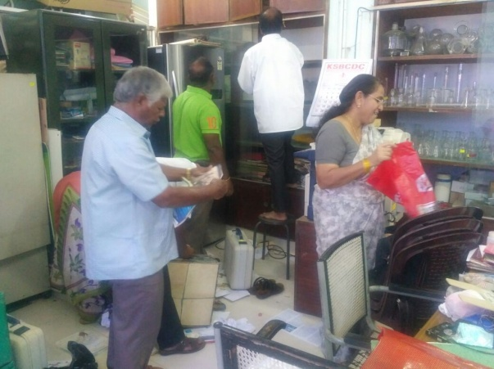

Photos above:- The Staff members of ICAR-CIFRI, Kochi are cleaning Office premises.

